Home page

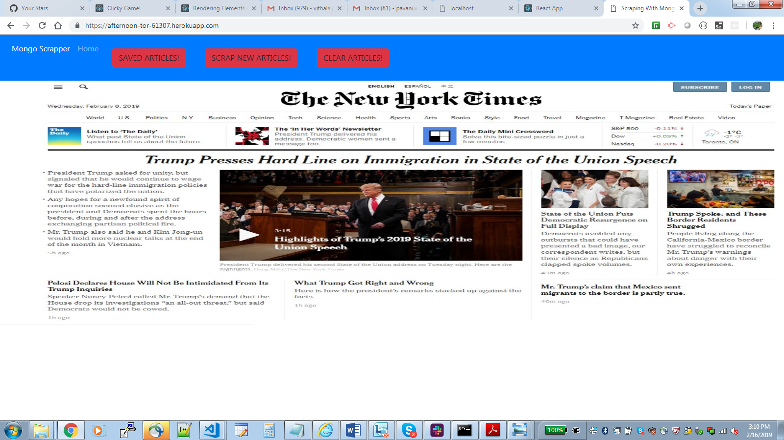

Click on Mongo Scrapper link – Page is refreshed



Click on Home button and page is refreshed



Click on Scrap articles button.New articles are scrapped and displayed at the bottom of the screen

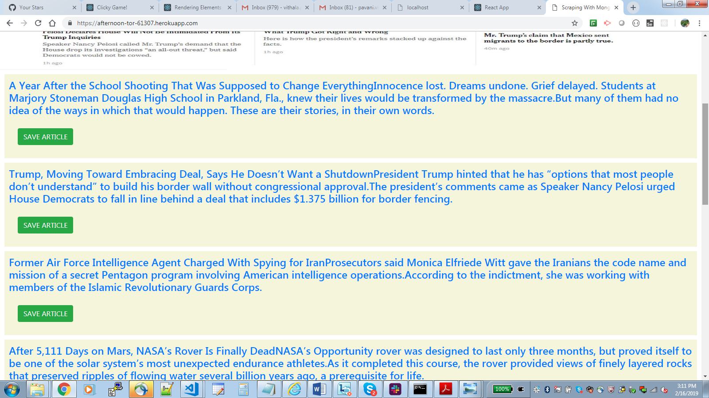

Click on SAVE ARTICLE button. The article is saved and disappears form the display section.

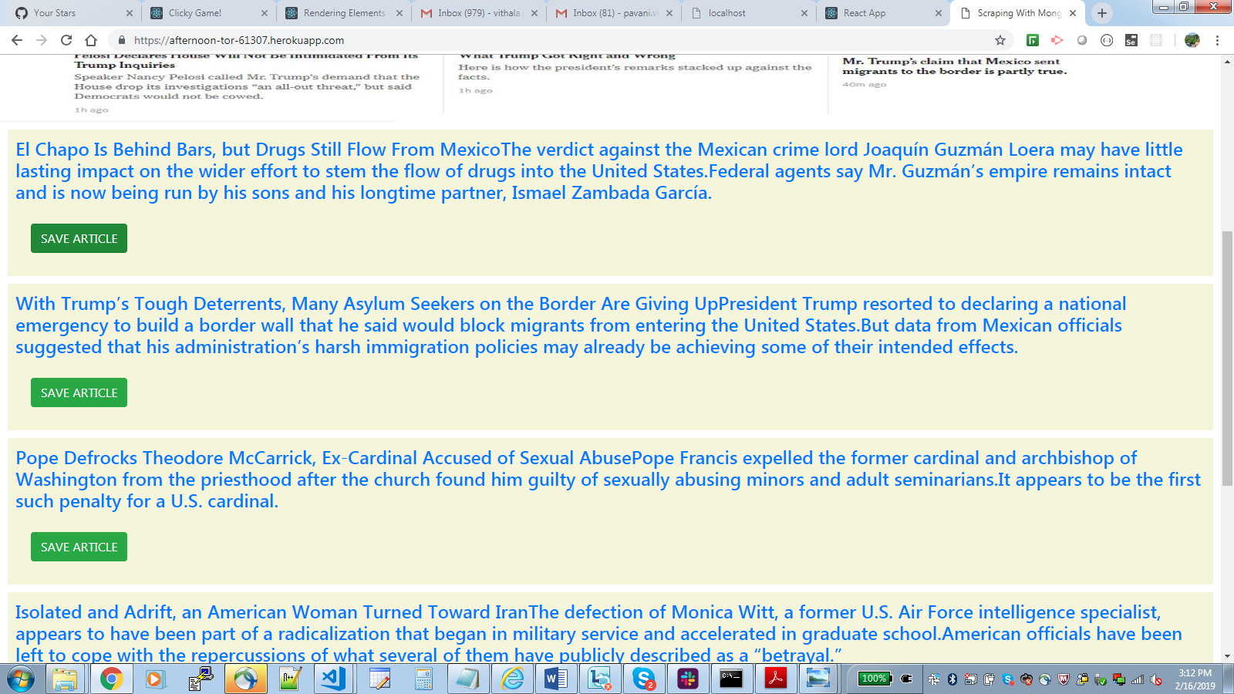

Click Home

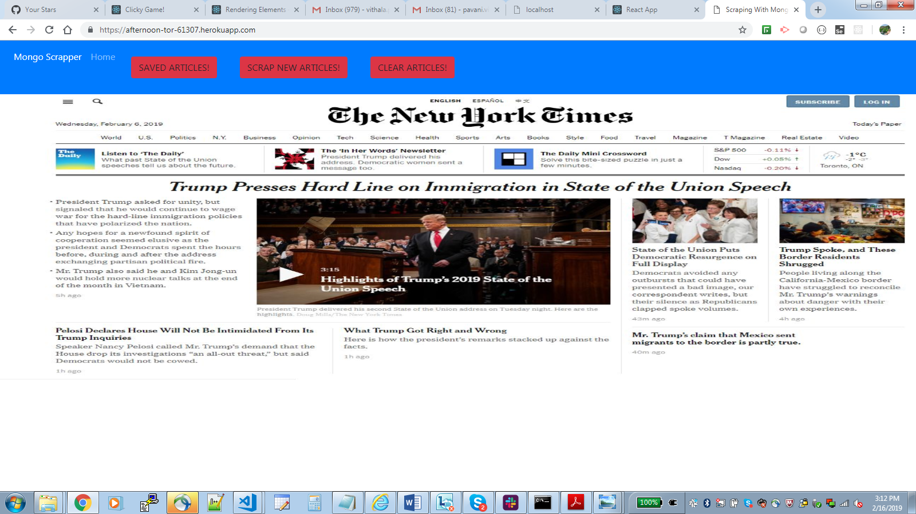

Click Saved Articles button. The saved articles are retrieved from DB along with DELETE ARTICLE and ADD NOTES options



Click DELETE ARTICLE button and the article is deleted from DB

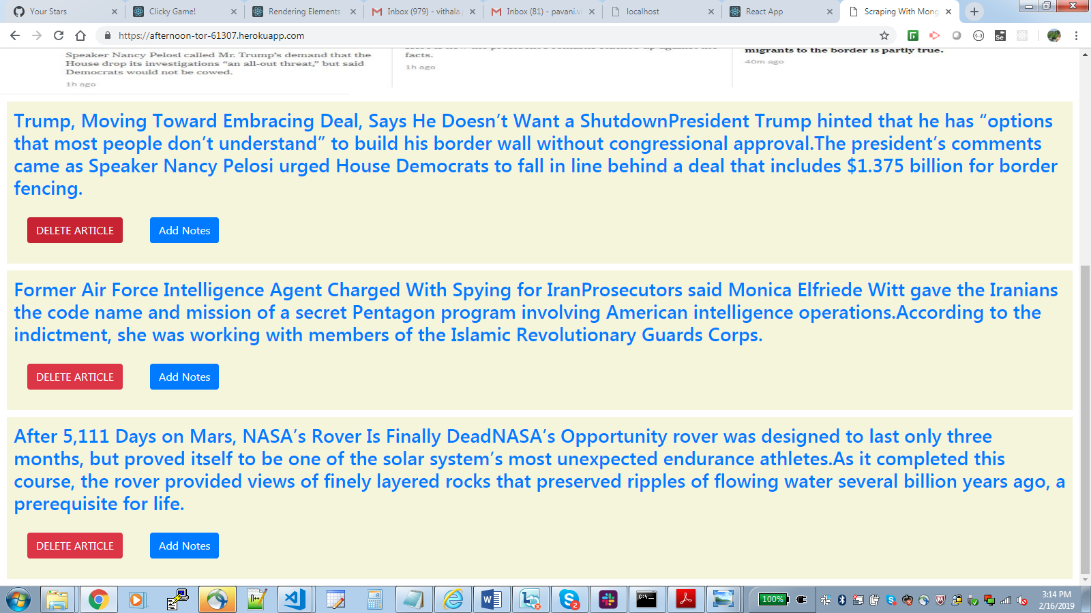

Click on Add Notes button to retrieved any existing notes as well as option to add new notes. A modal is displayed

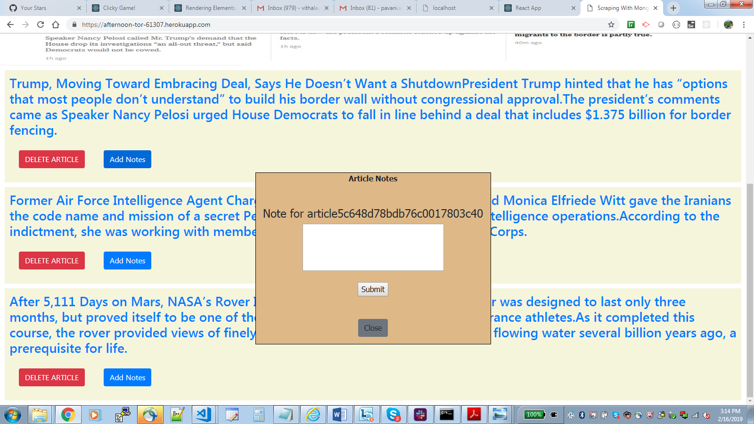

Add text in text area and click Submit

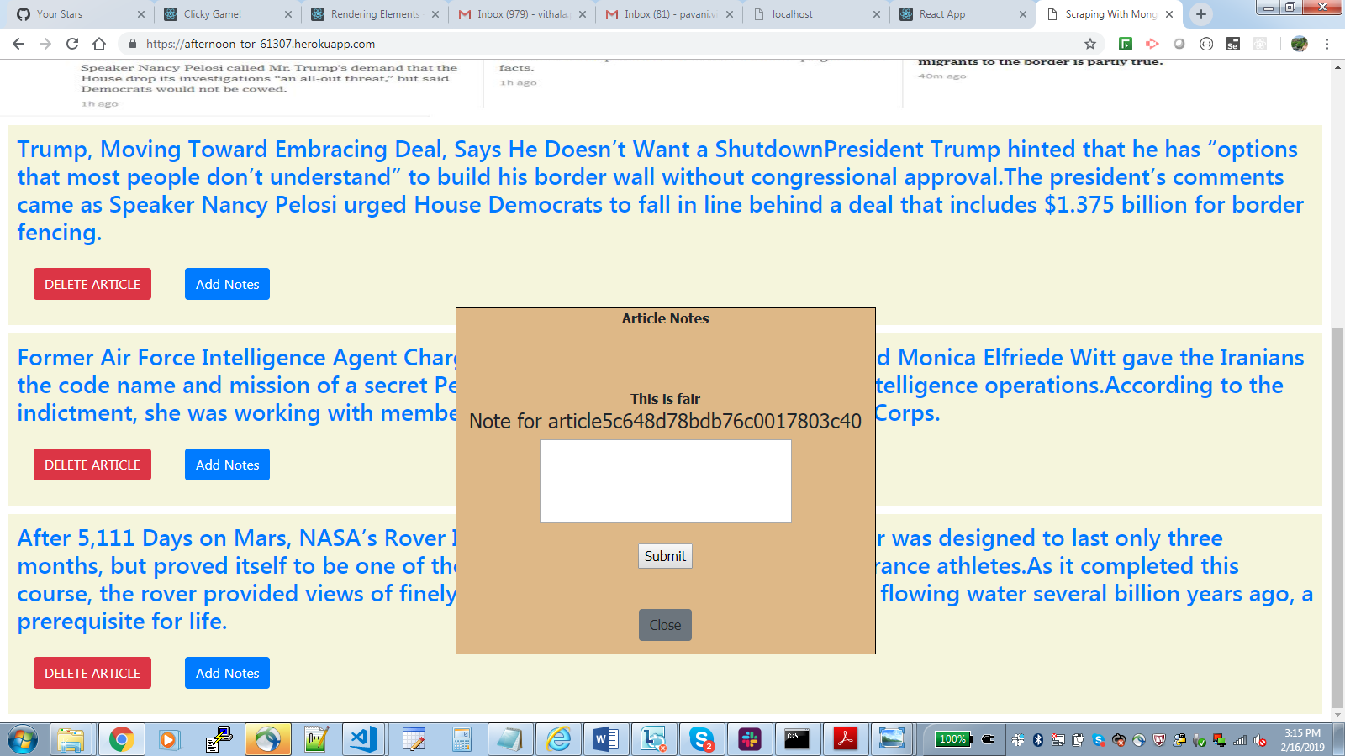

Click Close button to close the modal

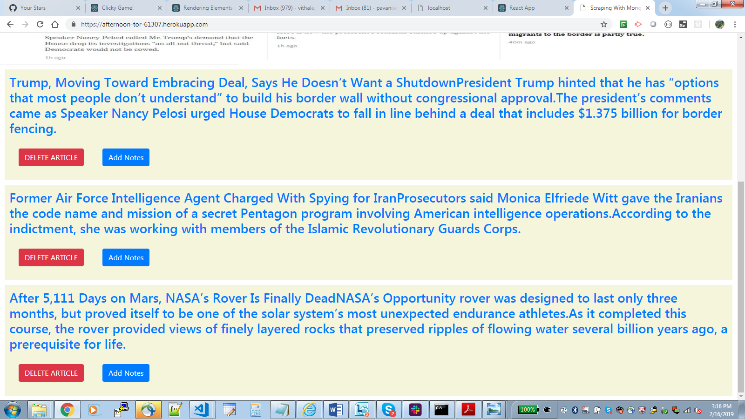

Click the add Note button on the article for which we added note. The note saved earlier is retrieved from DB

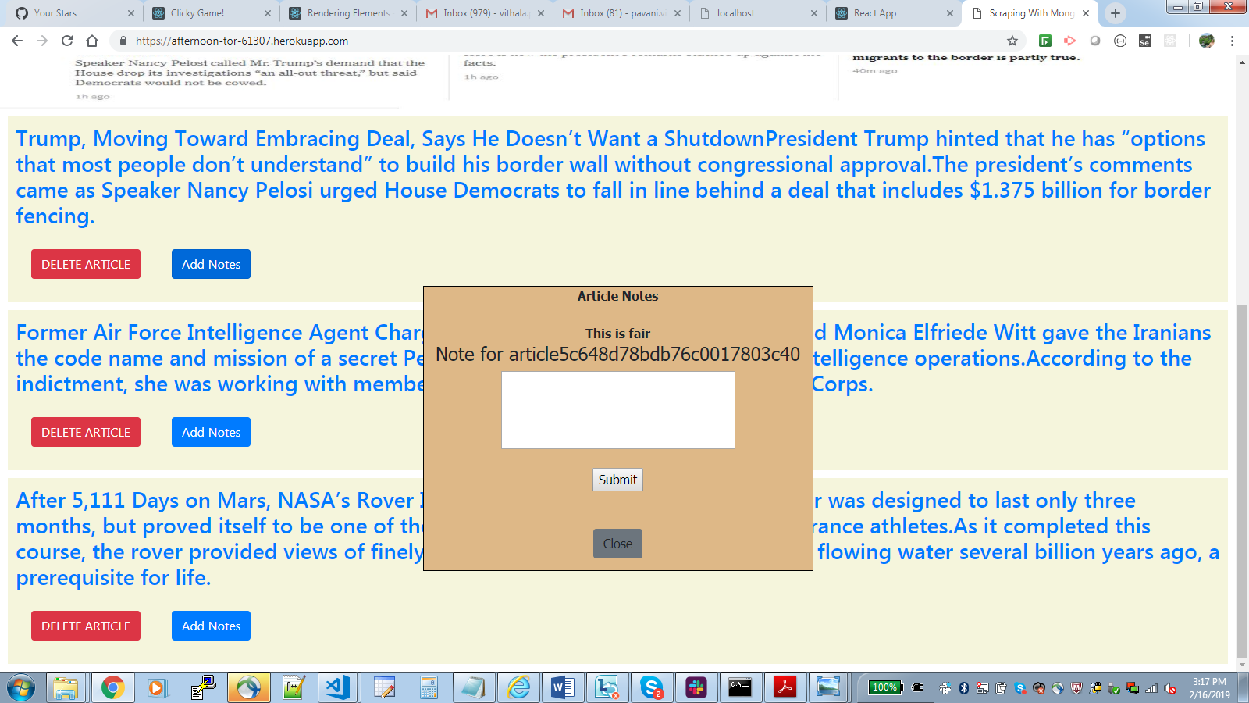

Click on any article and the whole story is displayed



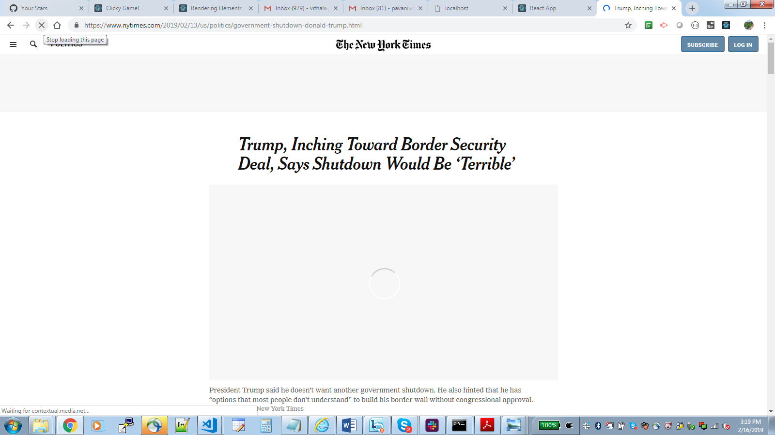

Click on Clear Articles button to clear all scrapped articles from DB along with the associated notes